4 DAY DESTINATION WEDDINGS AND ROMANCE TRAVEL INDUSTRY CONFERENCE AND NETWORKING EVENT (IADWP) IN ISTANBUL, TURKEY
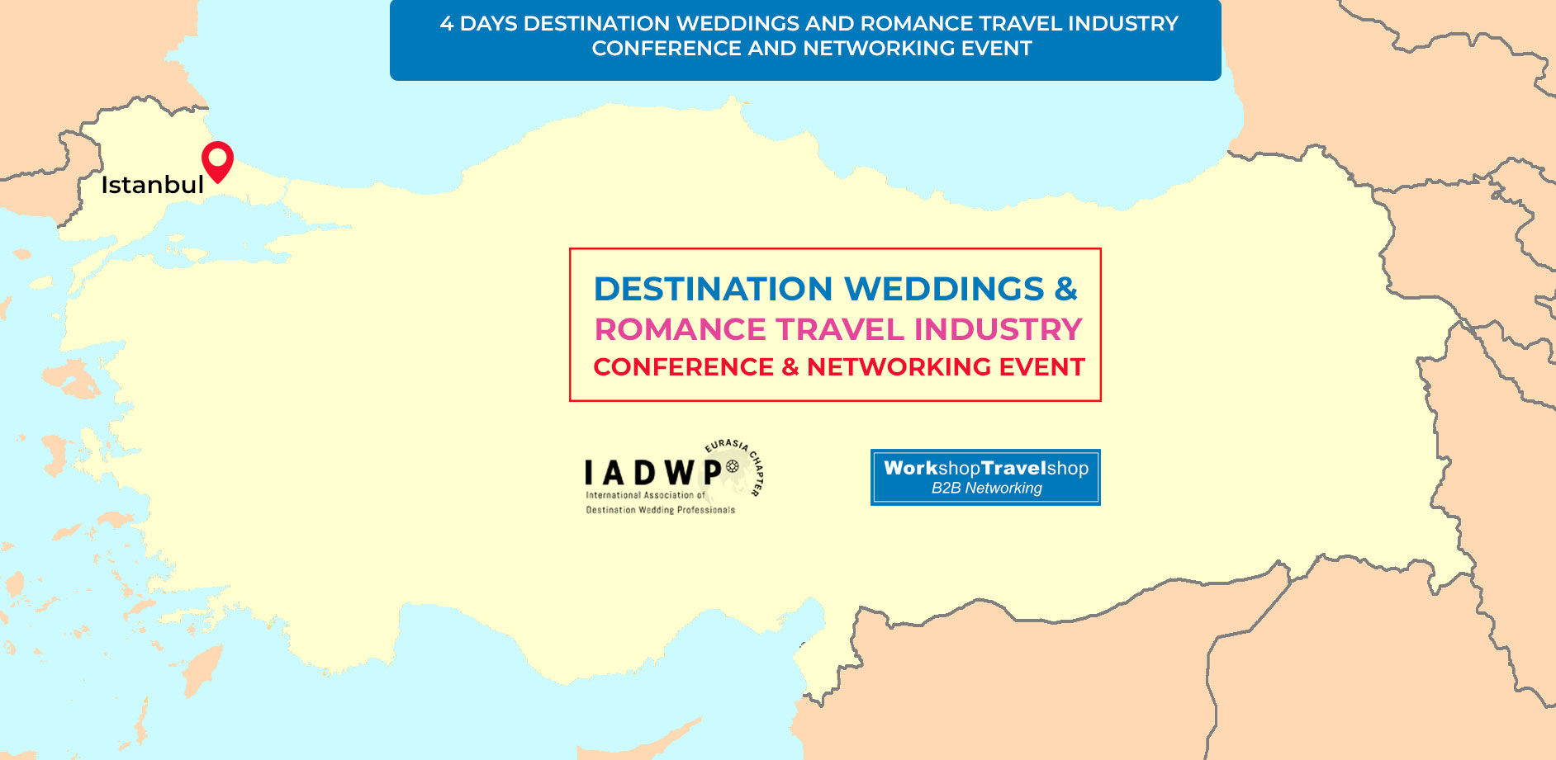
Tour Start Date: 20 October 2021, Wednesday
Tour Route: Istanbul
Summary
Destination Weddings and Romance Travel Industry that is steadily growing over the world will be gathering in one of the most unique destinations of the world, that is Istanbul Turkey the only city that resides on two continents of Asia and Europe at the same time.
As International Association of Destination Wedding Professionals, we organize an annual conference, Destination Weddings and Romance Travel Industry Conference and Networking Event (IADWP) and Business to Business Networking Event that is a widely considered the most important conference in destination weddings. This year we will hold the first IADWP Eurasia event in one of the wonderful destinations of Turkey, the beautiful city of Istanbul. The conference will take place on 21 October,2021. The B2B meetings among with hoteliers & hosted buyers will take place on 22 October, 2021.
We would like to contribute into this event by bringing Wedding Planners and Romance Travel Industry representatives from around the globe as Keynote Speakers to update the industry stakeholders, letting them benefit fully with the consideration of importance of destination weddings designing an exclusive program for the delegates.
We will make presentation via our Panelists and Speaker whom are the experts of the Destination Weddings and Romance Travel Industry that seems to grow stably every year, on the topics of the new rising trend of Destination Weddings and Romance Travel Tourism, their benefit, development and contribution on future business planning.

In this exclusive event, where the globally renowned Destination Weddings and Romance Travel Industry operators come together for mutually beneficial B2B networking sessions, you will have your chance to meet with potential partners, expand your business outreach and come across with many business opportunities to get you the leads that you demand from a corporate event.
In continuation of the event, you will have the opportunity to visit some of the great attractions and explore the uniquely beautiful wedding venues of Turkey on our Fam Trips.
Attendees will be able to see and discover the wedding related venues all around Turkey while having educational sightseeing tours in Turkey for a worthwhile experience. Our program covers most of unique destinations of beautiful Turkey.
Day 1: Arrival to Istanbul and Welcome Dinner (20 October 2021, Wednesday)
(Dinner Included)

Airport arrival transfer to Pullman Hotel between 07:00 and 22:00.
Welcome Dinner outside at the Lionel Hotel Istanbul from 20:00 to 22:00.
Overnight in Istanbul

Day 2: Destination Wedding (IADWP) Guest Speakers (21 October 2021, Thursday)
(Breakfast, Lunch, Coffee Breaks, Dinner Included)

From 07:00 to 09:00 Breakfast
Registration Process from 09:00 to 10:00
10:00 Opening Ceremony
10:30 to 12:30 Guest Speaker Session
12:30 to 13:00 Lunch Break
13:30 to 15:30 Guest Speaker Session Resume
15:30 to 15:45 Coffee Break
15:45 to 17:00 Final Speaker Session
19:00 depart for dinner
19:30 – 22:30 dinner at Bosphorus Cruise
Overnight in Istanbul

Day 3: Destination Weddings and Romance Industry Professionals B2B Meetings
(22 October 2021, Friday)
(Breakfast, Lunch, Coffee Breaks, Gala Dinner Included)

From 07:00 to 09:30 Breakfast
10:00 - 11.30 Destination Weddings and Romance Industry Professionals B2B Meetings
11:30 to 11:45 Coffee Break
11:45 to 12:45 B2B Meetings Resumed
12:45 to 14:00 Lunch Break
14:00 to 15:30 Continue with B2B Meetings
15:30 to 15:45 Coffee Break
15:45 to 17:30 continue with B2B Meetings
19:00 – 23:30 Award Ceremony & Gala Dinner at Pullman Hotel
Overnight in Istanbul

Day 4: Final Day for IADWP Event (23 October 2021, Saturday)
(Breakfast Included)

After the breakfast from 07:00 to 09:30, we shall depart for “Istanbul City” Tour applicable for only those with late departure flights after 17:00. During the Istanbul tour you will visit Hagia Sophia, Blue Mosque, Ancient Hippodrome and shopping spree in Istanbul.

Early departures to be sent off to Airport via transfer services provided.

