7 DAYS B2B HOLY LANDS WORKSHOP AND JEWISH HERITAGE FAM TRIP

Tour Start Date: 7 November 2021, Sunday

Tour Route: Istanbul, Izmir, Istanbul
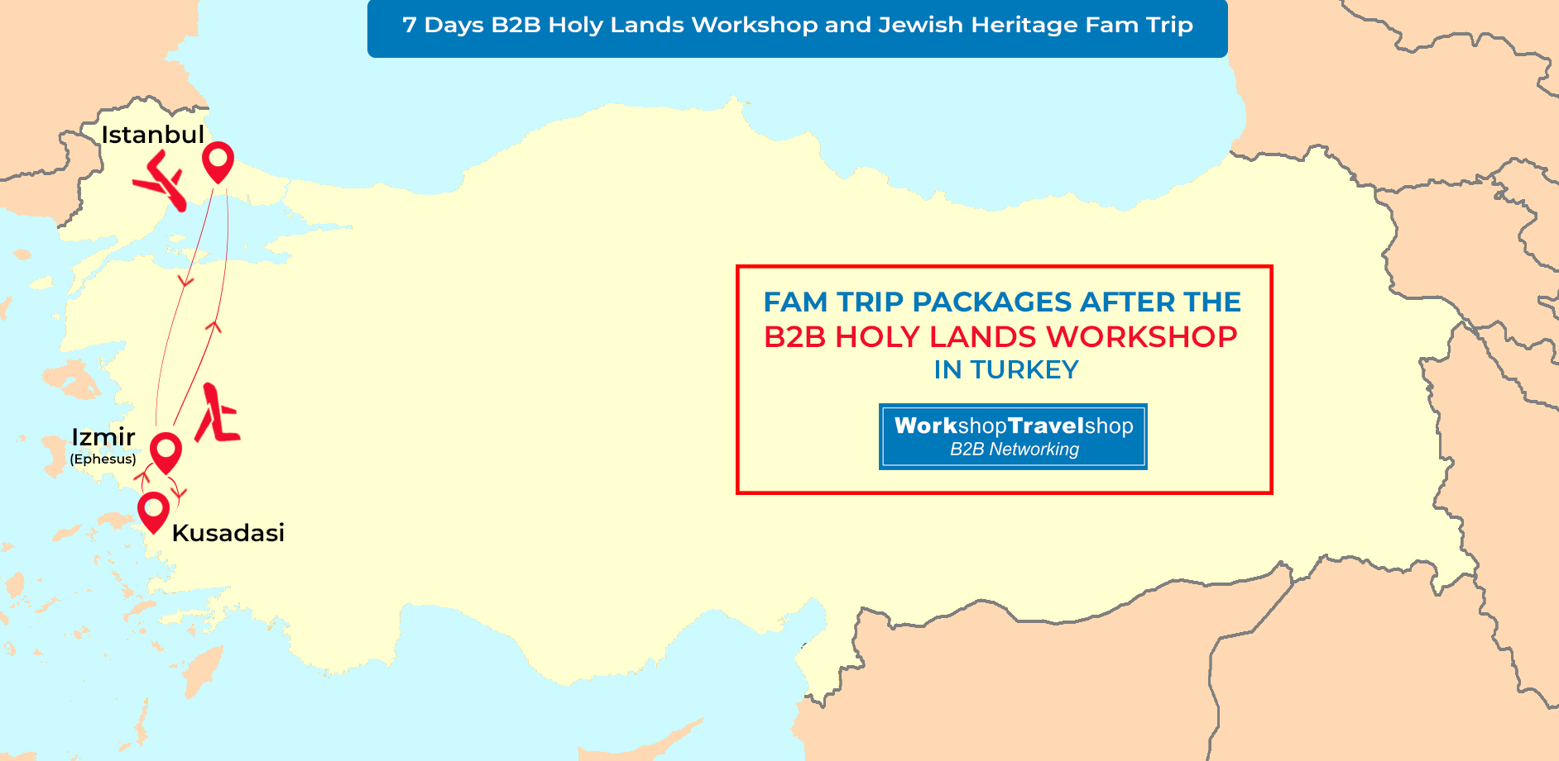

Summary
We design very attractive event and Fam Trips for those willing to promote the Jewish Heritage religious tour destinations and historical tours. Turkey is one of the “escape” destinations for Holy Lands. This Fam Trip will expand your portfolio in the field of Jewish Heritage religious destinations & historical sites and great opportunity to see it all by your own eyes in Turkey Including Galata tower – Synagogues - Neve Shalom - The Askenazy Synagogue St. Sophia - Balat neighborhood - 15th Ahrida - Yanbol synagogues - Jewish home. You will get a chance to have B2B Meetings with our elite Agencies worldwide to improve your business further.
Route : Istanbul – Hagia Sophia Mosque, Blue Mosque, ancient Hippodrome, Ephesus ancient city, Virgin Mary House and Sirince Village, Galata Tower, Synagogues, Neve Shalom, The Askenazy Synagogue St. Sophia, Balat neighborhood, 15th Ahrida and Yanbol synagogues.
Day 1 - Istanbul - Arrival Day – (7 November 2021, Sunday)
Dinner Included
Welcome to Turkey! Meet at the airport, transfer to your hotel. You will be given your room key and the rest of the day is yours to explore Istanbul. Dinner and Overnight in Istanbul. Please note that; Our arrival airport transfer services will be available between 07:00am to 22:00pm from Istanbul Airport.
Day 2 - Istanbul City Tour - Izmir - (8 November 2021, Monday)
Breakfast, Lunch, Dinner Included
After breakfast, at 09:00 am depart for a half day Istanbul City Tour A quick glance of exterior of. Hagia Sophia Mosque, formerly known as the Church of Divine Wisdom, is simply the best of its kind which is the greatest surviving example of Byzantine Architecture! When it was built, the temple itself was so rich and artistically ornamented that the Roman Emperor Justinianus proclaimed it as his greatest masterpiece. SULTANAHMET IMPERIAL MOSQUE Across from St. Sophia built in the 16th century by the architect Mehmet, is known as the BLUE MOSQUE because of its magnificent interior decoration of blue Iznik tiles. HIPPODROME Ancient Hippodrome, the scene of chariot races, with the three monuments; the Obelisk of Theodosius, the bronze Serpentine Column and the Column of Constantine. We will visit the unique Leather Factory ‘s leather fashion show. Murti’s Tour will then take you to the GRAND SPICE BAZAAR where the air here is filled with the enticing aromas of cinnamon, caraway, saffron, mint, thyme and every other conceivable herb and spice. Upon completion of our tour will have lunch. We depart for airport in Istanbul to fly to Izmir. Overnight in Kusadasi.
Day 3 - Kusadasi - Ephesus Tour - Turkish Village Sirince – (9 November 2021, Tuesday)
Breakfast, Lunch, Dinner Included
08:30 Departure from hotel fully guided tour of Ephesus, one of the best preserved ancient sites in the world en - route, visiting the Temple of Artemis, Curetes street, famous Roman baths, Celsus Library, Grand theatre and House of the Virgin Mary. Lunch break around 13:00pm. After the lunch, we will visit a place which continues to perform one of the oldest arts of Turkey; a carpet weaving centre. After Lunch we will do a Turkish Village Tour. Sirinces construction style today belongs to Anatolian Greeks. The houses on the slope are all Orginal with their white paints. Sirince Village also has a fantastic reputation for making some of the best wines in Turkey - especially fruit wines. We will visit the vineyards and it is time to learn how to make fruit wine with Turkish wine makers. In the evening you will be tested about your knowledge of making fruit wine. On the way we will visit one of the famous leather production centers of the region, where you will have the opportunity to get a good factory rate. On this guided tour, you will avoid the constant nagging and sometimes bullying that is well known in the markets of Turkey. Enabling you to enjoy the shopping experience whilst gaining the knowledge of the ancient craftsmen Overnight in Kusadasi.
Day 4 - B2B Holy Land Workshop and Guest Speakers - (10 November 2021, Wednesday)
Breakfast, Lunch, Dinner Included
From 07:00 to 09:00 Breakfast followed by Registration Process from 09:00 to 10:00
By 10:00 Opening Ceremony
From 10:30 to 12:30 Guest Speakers Session
12:30 to 13:00 Lunch Break
(13.00 – 13:30) Registrations
(14.00 - 17.00) B2B Workshop Event
This evening we will have a Gala Dinner between 19:30pm and 22:30pm Overnight in Izmir.
Day 5 - Izmir to Istanbul – by Domestic flight – Jewish Tour - (11 November 2021, Thursday)
Breakfast, Lunch, Dinner Included
After breakfast you depart for Izmir Airport for domestic flight to Istanbul. Arrive to Istanbul and Visit of the Balat neighborhood where you will see the star of David appearing on building facades. Visit the 15th Ahrida and the Yanbol synagogues. Visit the Jewish home for the elderly along the Golden Horn. Overnight in Istanbul.
Day 6 - Istanbul Jewish Synagogue Tour - (12 November 2021, Friday)
Breakfast, Lunch, Dinner Included
Morning visit to a Jewish neighborhood, Galata. You will see the Galata tower built by the Genoese in 1303. Visit the local synagogues, Neve Shalom and the Askenazy Synagogue. After lunch, visit the Hippodrome, a 3rd century site, where chariots raced during the Roman period. Visit the Blue Mosque, famous for its blue tiles and six minarets. Visit St. Sophia, a world heritage site built in the 6th century. Overnight in Istanbul.
Day 7 - Istanbul - End of Tour - (13 November 2021, Saturday)
Breakfast Included
We hope your tour was a memorable one and we would like to see you in the future in one of our B2B WorkShopTravelShop organization again. After breakfast check out from the hotel. We make your return airport transfer services. Have a nice trip back home and thanks for choosing WorkShopTravelShop.

INCLUDES
- Airport transfer services mentioned in the tour itinerary
- Domestic flights from Istanbul to Izmir
- Domestic flights from Izmir to Istanbul
- 3 Nights’ hotel accommodation in Istanbul
- 3 Nights’ hotel accommodation in Izmir
- 6 Open Buffet Breakfasts
- 5 Lunches
- 5 Dinners
- 1 Gala Dinner
- Guided Istanbul City Tour
- Guided Ephesus Tour - Turkish Village Sirince
- Guided Istanbul Jewish Tour
- Guided Istanbul Jewish Synagogue Tour
- B2B Workshop Networking Event
- Professional English speaking tour guides
- Transportation in a fully air-conditioned, non-smoking coach
- Return transfer to your hotel
- Holy Lands Workshop Guest Speaker Sessions

7 DAYS B2B HOLY LANDS WORKSHOP AND JEWISH HERITAGE FAM TRIP, TURKEY REGISTRATION FEES PER PERSON IN EURO
Discount Prices Available Date
Published Rates
275 €
SINGLE ROOM or DOUBLE / TWINE ROOM SHARED BY THE SAME COMPANY

EXCLUDES
- International flights
- Insurance of all types
- Country entry Visa
- Items of a personal nature such as alcoholic beverages, cold drinks, laundry
- Any others expenses which are not mentioned within the included section

TERMS AND CONDITIONS
- Abide by the Workshop calendar.
- Act in line with departure times.
- Minimum 30 pre-appointments taken per Hosted Buyers that to be signed by the appointee.
- Hosted Buyers not to promote their own “incoming” services to the participants and if detected, would be disqualified and charged for the full fee.
- Accommodations assigned should be taken into consideration and may not be altered during the trip in Turkey.
- Flight details to be registered on the system and we are not responsible of transfer services for the ones that are not registered.
- Please check your appointments and business cards.
- Only registered parties can enroll in Hosted Buyer Program. No one else can be invited without prior permission. Only the officially invited ones may stay through the event.
- We are expecting all Hosted Buyers to pay necessary attention and care for this event.
- You can ask for help of our team to be located in Hosted Buyer area throughout the event.
- Accepted invitations to Hosted Buyers are non-transferable. In case, where the Hosted Buyer is no longer able to attend, another attendee from their organization may replace with a renewed application, placed 45 days prior.
- Hosted Buyers who do not inform the Organizer of their cancellation and do not participate in the program, will be deemed a No-Show at 100%.
- All cancellations are subject to a written request and to be confirmed in return.
- Land tours “only” cancellation policy: Booking day 25 % Non-refundable, 5 Weeks before 75% credit, 4 Weeks before Non-refundable.
- Tours with domestic flight cancellation policy: Booking day 50 % Non-refundable, 5 Weeks before 50% credit, 4 Weeks before Non refundable
P.S Whether you have altered the dates and/or any Event and Fam Trip purchases made by you from our product selection, you may use the credit by the rates as indicated above towards your purchases for the duration of 1 years on Workshop TravelShop events.

