8 DAYS B2B HOLY LANDS WORKSHOP & SEVEN CHURCHES FAM TRIP

Tour Start Date: 7 November 2021, Sunday

Tour Route: Istanbul, Izmir, Istanbul
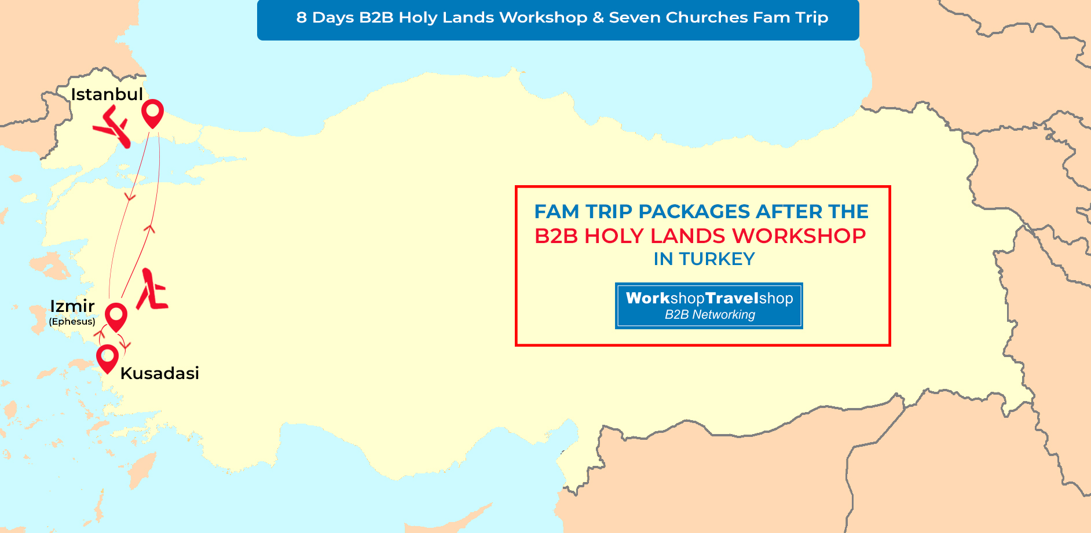

Summary
We design very good event and Fam Trips for those willing to promote the seven churches religious tour destinations and historical tours. Turkey is one of the “escape” destinations for Holy Lands. This Fam Trip will expand your portfolio in the field of religious destinations & historical sites and great opportunity to see it all by your own eyes in Turkey. Visit the seven biblical churches that paved a religion and a century of religion, now resting in the heart of Islamic Turkey. You will get a chance to have B2B Meetings with our elite Agencies worldwide to improve your business further.
Route : Istanbul – Hagia Sophia Mosque ,Blue Mosque, ancient Hippodrome, Ephesus ancient city, Virgin Mary House and Sirince Village, Smyrna (Izmir), Pergamon, Sardis – Philadelphia, Pamukkale, Hierapolis and Laodicea
Day 1 - Istanbul - Arrival Day – (7 November 2021, Sunday)
Dinner Included
Welcome to Turkey! Meet at the airport, transfer to your hotel. You will be given your room key and the rest of the day is yours to explore Istanbul. Dinner and Overnight in Istanbul. Please note that; Our arrival airport transfer services will be available between 07:00am to 22:00pm from Istanbul Airport.
Day 2 - Istanbul City Tour - Izmir - (8 November 2021, Monday)
Breakfast, Lunch, Dinner Included
After breakfast, at 09:00 am depart for a half day Istanbul City Tour A quick glance of exterior of Hagia Sophia Mosque, formerly known as the Church of Divine Wisdom, is simply the best of its kind which is the greatest surviving example of Byzantine Architecture! When it was built, the temple itself was so rich and artistically ornamented that the Roman Emperor Justinianus proclaimed it as his greatest masterpiece. SULTANAHMET IMPERIAL MOSQUE Across from St. Sophia built in the 16th century by the architect Mehmet, is known as the BLUE MOSQUE because of its magnificent interior decoration of blue Iznik tiles. HIPPODROME Ancient Hippodrome, the scene of chariot races, with the three monuments; the Obelisk of Theodosius, the bronze Serpentine Column and the Column of Constantine. We will visit the unique Leather Factory ‘s leather fashion show. Murti’s Tour will then take you to the GRAND SPICE BAZAAR where the air here is filled with the enticing aromas of cinnamon, caraway, saffron, mint, thyme and every other conceivable herb and spice. Upon completion of our tour will have lunch. We depart for airport in Istanbul to fly to Izmir. Overnight in Kusadasi.
Day 3 - Kusadasi - Ephesus Tour - Turkish Village Sirince – (9 November 2021, Tuesday)
Breakfast, Lunch, Dinner Included
08:30 Departure from hotel fully guided tour of Ephesus, one of the best preserved ancient sites in the world en - route, visiting the Temple of Artemis, Curetes street, famous Roman baths, Celsus Library, Grand theatre and House of the Virgin Mary. Lunch break around 13:00pm. After the lunch, we will visit a place which continues to perform one of the oldest arts of Turkey; a carpet weaving centre. After Lunch we will do a Turkish Village Tour. Sirinces construction style today belongs to Anatolian Greeks. The houses on the slope are all Orginal with their white paints. Sirince Village also has a fantastic reputation for making some of the best wines in Turkey - especially fruit wines. We will visit the vineyards and it is time to learn how to make fruit wine with Turkish wine makers. In the evening you will be tested about your knowledge of making fruit wine. On the way we will visit one of the famous leather production centers of the region, where you will have the opportunity to get a good factory rate. On this guided tour, you will avoid the constant nagging and sometimes bullying that is well known in the markets of Turkey. Enabling you to enjoy the shopping experience whilst gaining the knowledge of the ancient craftsmen Overnight in Kusadasi.
Day 4 - B2B Holy Land Workshop and Guest Speakers - (10 November 2021, Wednesday)
Breakfast, Lunch, Dinner Included
From 07:00 to 09:00 Breakfast followed by Registration Process from 09:00 to 10:00
By 10:00 Opening Ceremony
From 10:30 to 12:30 Guest Speakers Session
12:30 to 13:00 Lunch Break
(13.00 – 13:30) Registrations
(14.00 - 17.00) B2B Workshop Event
This evening we will have a Gala Dinner between 19:30pm and 22:30pm Overnight in Izmir.
Day 5 - Pergamon - Thyatira - Izmir (11 November 2021, Thursday)
Breakfast, Lunch, Dinner Included
After breakfast, we drive to Pergamon, actually called Bergama. It is one of the sites of the Seven Churches of Asia [Rev. 1:11; 2:12]. Here we explore the impressive Acropolis, the steepest theatre in the world, the Asklepieion, famous medical center of classical times, see the Altar of Zeus which is mentioned as the «Throne of Satan» in the book of Revelation, the marble columns of the Temple of Trajan and the Library which was foremost in the world and was long a rival of the equally famous Library of Alexandria in Egypt. Its wealth of volumes was estimated at over 200, 000. It inspired the invention of parchment. We also visit the Red Basilica (St. Johns Church). Buffet lunch is provided at a local restaurant. Then we continue our visit to Thyatira, now called Akhisar, another one of the Seven Churches of Asia [Rev. 1:11; 2:18 - 24; Acts 16:14]. It was a city famous for purple dyes. We visit the remains of a basilica and some architectural fragments from the Roman period. Lydia, the seller of purple in Philippi, was from Thyatira. Before we check in at the hotel in Izmir, we enjoy a panoramic ride of Smyrna, the third largest city in Turkey and one of the sites of the Seven Churches of Asia [Rev. 2:12 - 17]. Smyrnas is a city scarred with a bloody history of trade and warfare. We ascend to Mount Pagus where we visit the Citadel of Lysimachos, commander of Alexander the Great, erected in the 4th century BC. We will also see the Clock Tower. Check in at the hotel for dinner. Dinner and Overnight in Izmir.
Day 6 - Izmir - Sardis - Philadelphia - Hierapolis (12 November 2021, Friday)
Breakfast, Lunch, Dinner Included
Today we depart early in the morning to one of the most picturesque areas of any of the Seven Churches of Asia [Rev. 1.11; 3,1 - 4], Sardis, presently Sart. This was the capital of the ancient Lydian kingdom of the 6th century BC, portrayed as a dying church. We visit the great Temple of Artemis and the Temple of Cybele, which became a Byzantine Church. We will also visit the restored gymnasium and reconstructed Synagogue. We also see the last several meters of the royal Persian Road from Susa to Sardis built by Cyrus the Great and the «golden» river Pactolos. Lunch en route. Then we continue our journey to Philadelphia, nowadays called Alasehir, another church of the Seven Churches of Asia [Rev. 1.11; 3,7], and the only church not censured. There we see the remains of a Byzantine basilica built of brick, with a bit of high arch and some 11th century frescoes. We drive to the healing city of Hierapolis, actually Pamukkale, the white «cotton fortress» where hot mineral water bursts from the earth and cascades over steep cliffs forming pools, channels and stalactites. The therapeutic waters were known to the founders of Hierapolis and of Laodicea in 190 BC. In Hierapolis [Col. 4.13] we visit the Martyrium of the Apostle Philip where he was martyred during the persecutions ordered by Domitian. We visit the Gate of Domitian, the Arcadian Way, the 2nd century AD Theatre, the Nymphaion, the Temple of Apollo, the Plutonium and the Necropolis. Dinner and overnight in Pamukkale.
Day 7 - Laodicea - Aphrodisias - Izmir (13 November 2021, Saturday)
Breakfast, Lunch, Dinner Included
We depart for Laodicea (present name Denizli) yet another of the Seven Churches of Asia Minor [Rev. 1:11; 3:14; Col. 2:1; 4:13 - 16]. We see the ancient theatre, the remains of basilica and ancient stone water pipes. Aphrodisias is our next stop. We visit the best - preserved ancient stadium ever excavated where the seating capacity was 30, 000. We see the odeon with its extraordinary blue marble stage, the Temple of Aphrodite that marks the site of ancient veneration, Hadrian’s Bath and the Bishop’s Palace, part of a building christened by the archaeologists. Drive to Izmir. Dinner and overnight.Izmir.
Day 8 - Izmir to Istanbul - End of Tour - (14 November 2021, Sunday)
Breakfast Included
After breakfast today, we depart for Izmir Airport for our domestic flight to Istanbul and then back to home. We hope you have a memorable time in Turkey and we look forward to seeing you in the future on another B2B WorkShopTravelShop organization. Have a safe trip back home and thank you for choosing WorkShopTravelShop.

INCLUDES
- Airport transfer services mentioned in the tour itinerary
- Domestic flights from Istanbul to Izmir
- Domestic flights from Izmir to Istanbul
- 1 Night hotel accommodation in Istanbul
- 5 Nights hotel accommodation in Izmir
- 1 Night hotel accommodation in Pamukkale
- 7 Open Buffet Breakfasts
- 6 Lunches
- 6 Dinners
- 1 Gala Dinner
- Guided Istanbul City Tour
- Guided Ephesus Tour - Turkish Village Sirince
- B2B Workshop Networking Event
- Guided Pergamon – Thyatira Tour
- Guided Sardis - Philadelphia – Hierapolis Tour
- Guided Laodicea – Aphrodisias Tour
- Professional English speaking tour guides
- Transportation in a fully air-conditioned, non-smoking coach
- Return transfer to your hotel
- Holy Lands Workshop Guest Speaker Sessions

8 DAYS B2B HOLY LANDS WORKSHOP & SEVEN CHURCHES FAM TRIP, TURKEY REGISTRATION FEES PER PERSON IN EURO
Discount Prices Available Date
Published Rates
275 €
SINGLE ROOM or DOUBLE / TWINE ROOM SHARED BY THE SAME COMPANY

EXCLUDES
- International flights
- Insurance of all types
- Country entry Visa
- Items of a personal nature such as alcoholic beverages, cold drinks, laundry
- Any others expenses which are not mentioned within the included section

TERMS AND CONDITIONS
- Abide by the Workshop calendar.
- Act in line with departure times.
- Minimum 30 pre-appointments taken per Hosted Buyers that to be signed by the appointee.
- Hosted Buyers not to promote their own “incoming” services to the participants and if detected, would be disqualified and charged for the full fee.
- Accommodations assigned should be taken into consideration and may not be altered during the trip in Turkey.
- Flight details to be registered on the system and we are not responsible of transfer services for the ones that are not registered.
- Please check your appointments and business cards.
- Only registered parties can enroll in Hosted Buyer Program. No one else can be invited without prior permission. Only the officially invited ones may stay through the event.
- We are expecting all Hosted Buyers to pay necessary attention and care for this event.
- You can ask for help of our team to be located in Hosted Buyer area throughout the event.
- Accepted invitations to Hosted Buyers are non-transferable. In case, where the Hosted Buyer is no longer able to attend, another attendee from their organization may replace with a renewed application, placed 45 days prior.
- Hosted Buyers who do not inform the Organizer of their cancellation and do not participate in the program, will be deemed a No-Show at 100%.
- All cancellations are subject to a written request and to be confirmed in return.
- Land tours “only” cancellation policy: Booking day 25 % Non-refundable, 5 Weeks before 75% credit, 4 Weeks before Non-refundable.
- Tours with domestic flight cancellation policy: Booking day 50 % Non-refundable, 5 Weeks before 50% credit, 4 Weeks before Non refundable
P.S Whether you have altered the dates and/or any Event and Fam Trip purchases made by you from our product selection, you may use the credit by the rates as indicated above towards your purchases for the duration of 1 years on Workshop TravelShop events.

