EUROPE AND BALKANS COMBINED COUNTRY, MULTI-DESTINATION FAM TRIP EVENT ITINERARY

Tour Start Date: 07 November 2022, Monday
Tour Route: Istanbul
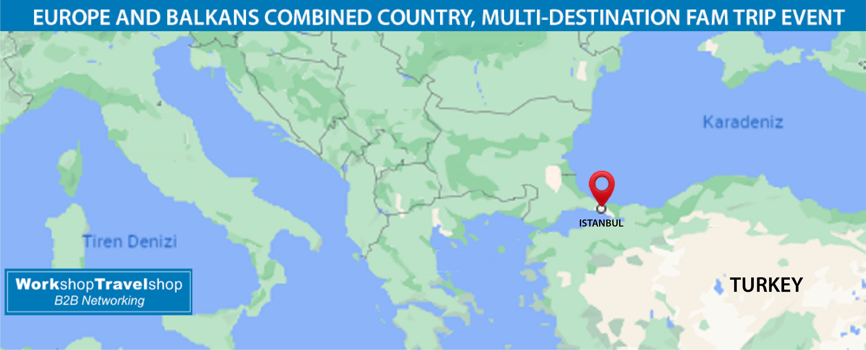

Summary
You will explore the majestic Istanbul that is European Culture Capital of the world that sits in the middle of Asia and Europe that the thousand years of history witnessed the century old civilizations.History, culture, nature, entertainment, shopping and more is found with a great variety in Istanbul that will surely give you life time memories that are hard to forget.
Day 1 – Istanbul - Arrival Day – (07 Nov 2022, Monday)
Dinner Included
Welcome to Istanbul! Upon your arrival at Istanbul Airport / Sabiha Gokcen Airport our representative will meet you at the international arrivals exit gate, inside the airport and transfer to your hotel. You will be given your room key and the rest of the day is yours to explore Istanbul. There are two airports in Istanbul. Istanbul New Airport is 50 km away from the city center and Sabiha Gokcen airport is 55 km away from city center. Please note that; Our arrival airport transfer services will be available between 07:00am to 22:00pm from Istanbul Airport.

Day 2 - Istanbul City Tour - (08 Nov 2022, Tuesday)
Breakfast, Lunch, Dinner Included
Pick up at 08:30 from your hotel for the daily tour of old Istanbul city. Hagia Sophia Mosque, formerly known as the Church of Divine Wisdom, is simply the best of its kind which is the greatest surviving example of Byzantine Architecture! When it was built, the temple itself was so rich and artistically ornamented that the Roman Emperor Justinianus proclaimed it as his greatest masterpiece. SULTANAHMET IMPERIAL MOSQUE Across from St. Sophia built in the 16th century by the architect Mehmet, is known as the BLUE MOSQUE because of its magnificent interior decoration of blue Iznik tiles. HIPPODROME Ancient Hippodrome, the scene of chariot races, with the three monuments; the Obelisk of Theodosius, the bronze Serpentine Column and the Column of Constantine. Lunch break at 13:00pm, after the lunch, Murtis Tour will take you to the GRAND SPICE BAZAAR for Shopping and after shopping, come back to Hotel. Overnight in Istanbul.

Day 3 - Private Istanbul Bosporus Cruise and Half Day Conference – ( 09 Nov 2022, Wednesday)
Breakfast, Lunch, Dinner Included
Pickup time is about 08:30 am. (Approximately) from your hotel. We will take you to the Bosphorus Cruise, through the water way separating the two continents, Europe and Asia, with a possibility to take photographs of marble palaces, ancient wooden villas of Ottoman architecture besides modern residential and luxurious apartments. Rumeli Fortress (from the boat – no interior visit), historical armament built by the Conqueror to control and protect the Bosphorus. A unique example of military architecture. Lunch at around 13:00 pm. After lunch there will be a Half Day Conference and presentations about Travel Shop Turkey Programs. Overnight in Istanbul. -The boat trip is operated depending on weather conditions. The local cruise boats are with standard conditions and should not be considered of high quality deluxe boats, but rather daily operational boats to introduce you the Bosporus. Drinks are available on the boat at an extra charge.

Day 4 - Istanbul - End of Tour – ( 10 Nov 2022, Thursday)
Breakfast Included
After breakfast, check out from the hotel. We hope your tour was a memorable one and we look forward to seeing you in the future on another TravelShop Turkey Tour. Have a safe trip back home and thanks for choosing us.

INCLUDES
- 3 Nights' accommodation in Istanbul
- All coach transportation by fully equipped buses
- All Sightseeing Trips with entrance fees as above
- Professional English speaking Guide
- All meals ( Breakfast – Lunch – Dinner ) as mentioned in above Itinerary
- Professional English speaking tour guides
- Transportation in a fully air-conditioned, non-smoking coach
- Return transfer to your hotel
EXCLUDES
- International flights
- Taxes
- Insurance of all types
- Country entry Visa
- Items of a personal nature such as alcoholic beverages, cold drinks, laundry
- Any others expenses which are not mentioned within the included section
- Extra meals or Drinks not mentioned above
- Tips and Personal expenses

Terms & Condition

- Hosted Buyers who do not inform the Organizer of their cancellation and do not participate in the program, will be deemed a No-Show at 100%.
- All cancellations are subject to a written request and to be confirmed in return.
- Land tours only cancellation policy: Booking day 25 % Non-refundable, 5 Weeks before 75% credit, 4 Weeks before Non-refundable
- Tours with domestic flight cancellation policy: Booking day 50 % Non-refundable, 5 Weeks before 50% credit, 4 Weeks before Non refundable
P.S Whether you have altered the dates and/or any Event and Fam Trip purchases made by you from our product selection, you may use the credit by the rates as indicated above towards your purchases for the duration of 1 years on Workshop TravelShop events.

